In Celebration of and Thanksgiving for the Life of

Norman Charles Kayser
1935 – 2022
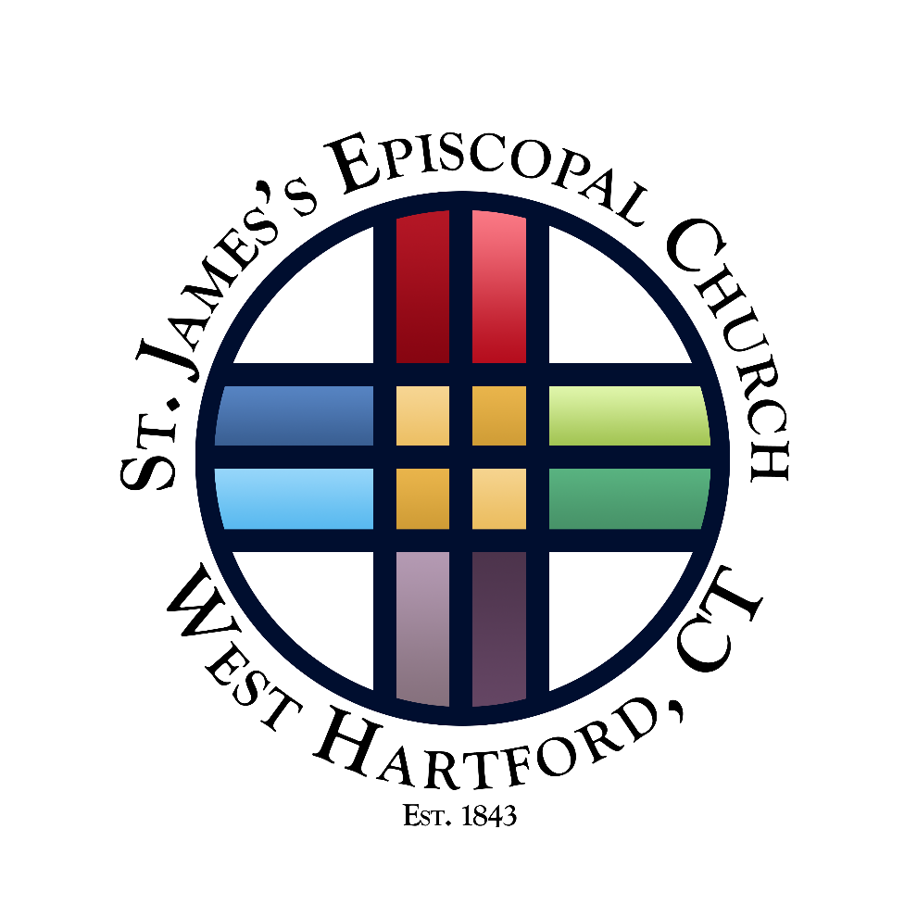

August 5, 2023

2:00 PM

A Celebration of the Life of
Norman Charles Kayser

August 5, 2023 at 2:00pm

Organ Voluntary Ave Maria Franz Schubert

Opening Hymn

Title: How Great Thou Art Words: Stuart K. Hine (1899-1989) Music: Traditional Swedish folk tune/adapt. Stuart K. Hine
Copyright: © 2003, ABC Music Co., All rights reserved. Reprinted with permission under ONE LICENSE #A-737832.

The Collects Page 493

The First Reading 1 Peter 1:3-9
Blessed be the God and Father of our Lord Jesus Christ! According to his great mercy, he has caused us to be born again to a living hope through the resurrection of Jesus Christ from the dead, to an inheritance that is imperishable, undefiled, and unfading, kept in heaven for you, who by God’s power are being guarded through faith for a salvation ready to be revealed in the last time. In this you rejoice, though now for a little while, if necessary, you have been grieved by various trials, so that the tested genuineness of your faith – more precious than gold that perishes though it is tested by fire – may be found to result in praise and glory and honor at the revelation of Jesus Christ. Though you have not seen him, you love him. Though you do not now see him, you believe in him and rejoice with joy that is inexpressible and filled with glory, obtaining the outcome of your faith, the salvation of your souls.

Reader The Word of the Lord.
People Thanks be to God.

Psalm 23 (Prayed in unison)
The Lord is my shepherd;
I shall not want.

He maketh me to lie down in green pastures:
he leadeth me beside the still waters.

He restoreth my soul:
he leadeth me in the paths of righteousness for his name’s sake.

Yes, though I walk through the valley of the shadow of death,
I will fear no evil: for thou art with me;
thy rod and thy staff they comfort me.

Thou prepares a table before me in the presence of mine enemies;
thou anointest my head with oil; my cup runneth over.

Surely goodness and mercy shall follow me all the days of my life,
and I will dwell in the house of the Lord for ever.

The Second Reading 1 Corinthians 13:4-13
Love is patient, love is kind. It does not envy, it does not boast, it is not proud. It is not rude, it is not self-seeking, it is not easily angered, it keeps no record of wrongs. Love does not delight in evil but rejoices with the truth. It always protects, always trusts, always hopes, always perseveres. Love never fails. But where there are prophecies, they will cease; where there are tongues, they will be stilled; where there is knowledge, it will pass away. For we know in part and we prophesy in part, but when perfection comes, the imperfect disappears. When I was a child, I talked like a child, I thought like a child, I reasoned like a child. When I became a man, I put childish ways behind me. Now we see but a poor reflection as in a mirror; then we shall see face to face. Now I know in part; then I shall know fully, even as I am fully known. And now these three remain: faith, hope and love. But the greatest of those is love.
Reader The Word of the Lord.
People Thanks be to God.

Hymn 662 Abide with me Eventide
Eulogies
The Apostles’ Creed Page 496

The Prayers Page 497

The Commendation Page 499
The Blessing and Dismissal Page 500
Recessional Hymn 579 Almighty Father, strong to save Melita
Organ Voluntary Chaconne Henry Purcell

The Committal (Taking place in the Memorial Garden)

The family invites you to a reception in the parish hall following the memorial service.

Participants in the Liturgy

Officiant
The Rev’d Robert C. Hooper, III
Assisting Clergy
The Rev’d Joseph J. Rose

Organist
The Rev’d Alan C. Murchie

Eulogists
Joan Kayser
Harold Smullen
John Byrnes
William Stahl
Lynne Kayser Parrott

Altar Guild
Chris Keesling

Flower Arrangements
Mary Ann Haar

Livestream Director
Jonathan Lewis

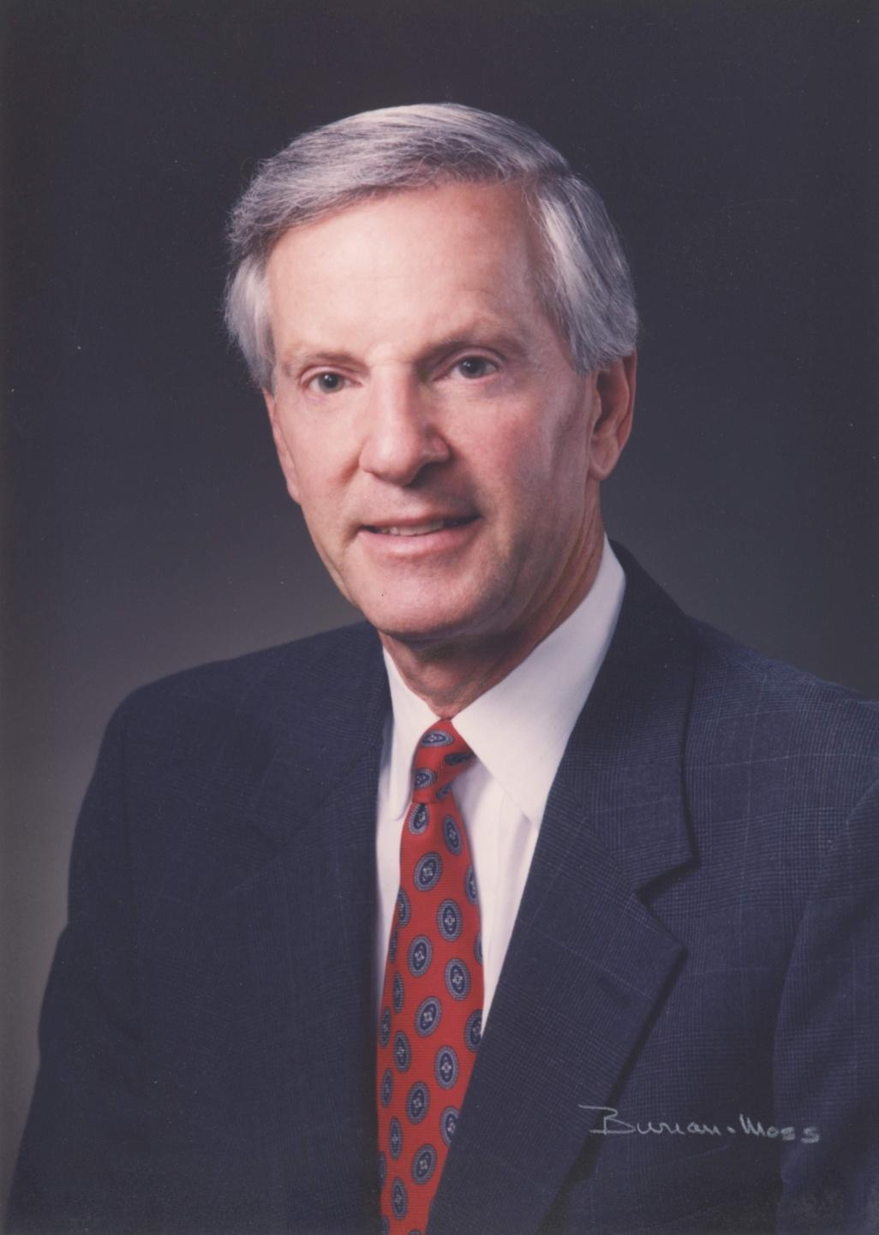
Norman Charles Kayser
August 4, 1935 – September 5, 2022

Tel 860.521.9620 St. James’s Episcopal Church

Email info@stjameswh.org 19 Walden Street, West Hartford, Connecticut 06107
@stjameswh www.stjameswh.org
The Rev. Robert C. Hooper III, Rector
The Rev. Joseph J. Rose, Assistant Rector
The Rev. Alan C. Murchie, Assoc. for Education & Music

